ORACLE

academy.oracle.com

Academy

Database Programming with SQL

2-2: Limit Rows Selected

Practice Activities

Objectives

* Apply SQL syntax to restrict the rows returned from a query
* Demonstrate application of the WHERE clause syntax
* Explain why it is important, from a business perspective, to be able to easily limit data retrieved from a table
* Construct and produce output using a SQL query containing character strings and date values

Vocabulary

Identify the vocabulary word for each definition below.

|  |  |
| --- | --- |
| Where Clause | Restricts the rows returned by a select statement |
| Comparison Operator (оператор сравнения) | Compares one expression to another value or expression |

Try It / Solve It

1. Using the Global Fast Foods database, retrieve the customer’s first name, last name, and address for the customer who uses ID 456.

Ответ:

SELECT first_name as "first name", last_name as "last name", address || ', ' || city || ', ' || state || '-' || zip || CHR(10) || '(Phone-' || phone_number || ')' as "address"

FROM f_customers

WHERE id = 456;

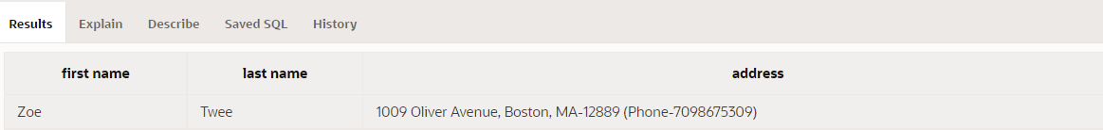

1. Show the name, start date, and end date for Global Fast Foods' promotional item “ballpen and highlighter” giveaway.

Ответ:

SELECT name, start_date as "start date", end_date as "end date"

FROM f_promotional_menus

WHERE give_away = 'ballpen and highlighter';



1. Create a SQL statement that produces the following output:

|  |
| --- |
| Oldest |
| The 1997 recording in our database is The Celebrants Live in Concert |

Ответ:

SELECT 'The ' || year ||' recording in our database is '|| title as "Oldest"

FROM d_cds

WHERE year = (SELECT MIN(year) FROM d_cds);

1. The following query was supposed to return the CD title “Carpe Diem" but no rows were returned. Correct the mistake in the statement and show the output.

SELECT produce, title FROM d_cds

WHERE title = 'carpe diem' ;

Ответ:

Ошибка была в том, что имя заголовка было указано с маленьких букв. Ниже исправленный запрос:

SELECT title

FROM d_cds

WHERE title = 'Carpe Diem' ;

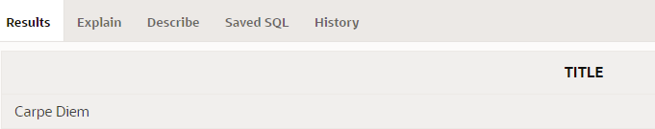

1. The manager of DJs on Demand would like a report of all the CD titles and years of CDs that were produced before 2000.

Ответ:

SELECT title, year

FROM d_cds

WHERE year < 2000;

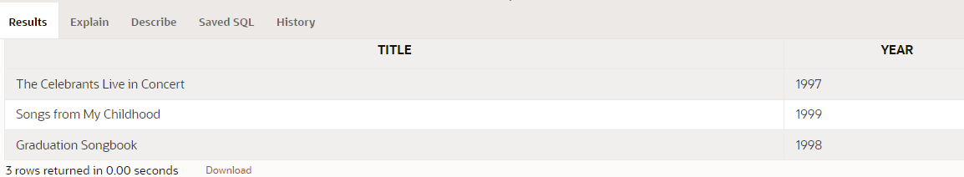

1. Which values will be selected in the following query?

SELECT salary

FROM employees

WHERE salary < = 5000;

1. 5000
2. 0 - 4999
3. 2500
4. 5

For the next three questions, use the following table information:

TABLE NAME: students

COLUMNS:

studentno NUMBER(6)

fname VARCHAR2(12)

lname VARCHAR(20)

sex CHAR(1)

major VARCHAR2(24)

Ответ:

Все вышеперечисленные значения

1. Write a SQL statement that will display the student number (studentno), first name (fname), and last name (lname) for all students who are female (F) in the table named students.

Ответ:

SELECT studentno as "student number", fname as "first name", lname as "last name"

FROM students

WHERE sex = 'F';

1. Write a SQL statement that will display the student number (studentno) of any student who has a PE major in the table named students. Title the studentno column Student Number.

Ответ:

SELECT studentno as "Student Number"

FROM students

WHERE major = 'PE';

1. Write a SQL statement that lists all information about all male students in the table named students.

Ответ:

SELECT *

FROM students

WHERE sex = 'M';

1. Write a SQL statement that will list the titles and years of all the DJs on Demand CDs that were not produced in 2000.

Ответ:

SELECT title, year

FROM d_cds

WHERE year != 2000;

1. Write a SQL statement that lists the Global Fast Foods employees who were born before 1980.

Ответ:

SELECT *

FROM f_staffs

WHERE birthdate < '01-JAN-1980';